Equality, diversity and Inclusion
For the Student Union Board of Imperial College London

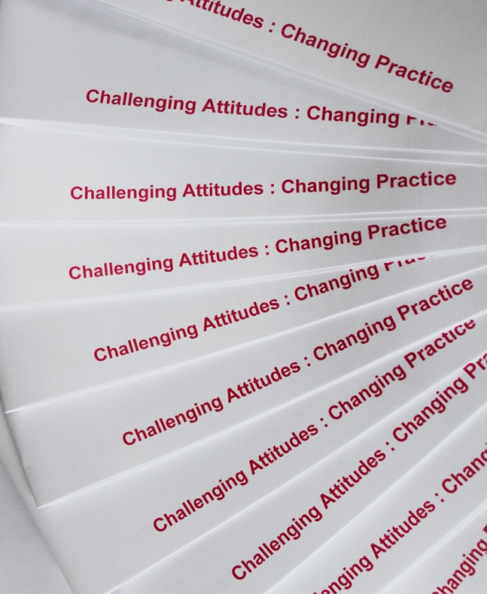
To:

Jill Finney
Imperial College

Contents

Introduction 3
Background 3
Our understanding of your requirement 3
Methodology 4
Inclusive Leadership for the Student Union Board 5
Trainer and Consultant 6
Investment 7
Contact 7

Introduction

Background
Thank you for considering Challenge Consultancy to undertake this project. This proposal has been produced following a telephone conversation and email communication between Jill Finney of Imperial College and Femi Otitoju of Challenge Consultancy. On the pages that follow, you will find a summary of our understanding of your requirements, a draft programme and information about our approach. We have also provided more detailed information on Femi and an indication of the investment needed.

Our understanding of your requirement
Imperial College Student Union is committed to the continued development and improvement of its activities to create an environment within which all academics, staff and students can fulfil their potential.
Imperial’s role as a university, demonstrating leadership behaviours that indicate a care and concern for its students and staff, and a commitment to engage and motivate them, will attract and retain the best people and ensure the best possible experience for its students.

Methodology

Having worked with the Boards of Provosts and Presidents we found that the short online survey was immensely helpful in determining how Board members felt about inclusive leadership and what changes they felt were needed at the University. We would propose a similar questionnaire for the Student Union Board.

The questionnaire will help highlight where members feel Imperial College London is currently doing well in relation to equality, diversity and inclusion and where they believe there are issues and challenges, and where improvements can be made. This survey will be similar to that completed by the Provost’s and President’s Boards. If a small number of Board members would prefer a telephone conversation, this can be arranged.

If a decision is made that the survey would be beneficial, we will use the results to adapt the recommended programme, ensuring the interventions reflect both the University’s and the Board’s needs. We will include appropriate available internal data and information.

The design and delivery of the session will ensure that Board members can raise issues which may be difficult in other circumstances. In our experience open discussions related to creating an inclusive environment may raise deeply held opinions which may need time to be explored. This is anticipated by utilising a variety of methods to engage the Board and provide them with the tools they need to meet the aims of the sessions.

Content and supporting materials

In advance of the event:

- Self-assessment questionnaire for individuals to benchmark themselves against content of the programme

During the event:

- A Model detailing a strategic approach to managing and leading on diversity and inclusion
- Drivers for inclusive leadership including: Imperial’s commitment and data

At the end of the event:

Participants will be provided with the following tools for individual utilisation

- A toolkit for addressing the manifestations and impact of unconscious bias
- Action plan monitoring proforma to evaluate progress

Equality diversity and inclusion Student Union Board

11 December 2019 duration 2hours

Aim

To provide a structured forum within which members of the Student Union Board can reflect on how they can contribute to the further development of a high performing leadership team.

Objectives

By the end of the session board members will be able to:

Outline their responsibilities as Board members in relation to Equality, Diversity and Inclusion (ED&I)

Recognise how to address ED&I issues in the way the Board functions

Understand the concept of Unconscious Bias and employ established mechanisms to minimise the way it affects the function of the board.

Content

During the session we will cover:

Imperial’s success on equality, diversity and inclusion
The business case for diversity and inclusion
The role of board members in furthering diversity and inclusion
How bias in constructed and how tackle it
Dignity and respect in board function
The way forward

Trainer and Consultant

Femi Otitoju – Managing Director
A charismatic and inspirational leader, Femi is a diversity and inclusion specialist with a career spanning over 30 years. Combining a scientific background with persuasive and engaging training skills, Femi is often described as a “gifted presenter”.
Femi founded Challenge Consultancy in 1985 to provide high quality, effective training and consulting services for the private, public and voluntary sectors. Since then the company has grown into an association of trainers and consultants designing and delivering solutions for a wide range of UK and global organisations.

Femi has designed much sought-after Unconscious Bias and Inclusive Leadership programmes and delivered a wide range of equality and diversity courses, cultural awareness, dignity at work, coaching, mediation and Board development services.

- She and Challenge have worked with student unions at King’s College London, London School of Economics, Northumbria University, University College London and the University of the Arts

- She has worked with staff at over half of the Russell Group universities including Cambridge, Oxford, King’s College London, Dundee and Cardiff

- Femi has worked in the voluntary and not-for profit sector with Action on Hearing Loss, Amnesty International UK, Centre for Expertise on Child Sexual Abuse, The Children’s Society, Diabetes UK, Equity, Girl Guiding, PLAN International and UNICEF

- Femi’s clients include the senior leadership teams at the BBC, Eli Lilly, Imperial College London, Nationwide, the United Bank Ltd, Viacom and Zenith Bank

- She has gained a reputation amongst central government departments such as Border Force, Department of Business Energy and Industrial Strategy, the Home Office and Ministry of Justice, as an interesting, innovative and trusted trainer and facilitator

- Femi has always enjoyed working in the Heritage Sector and can count English Heritage, the Royal Collection, the Tyne and Wear archives and museums, the V&A, the Natural History Museum, the Design Museum and Bletchley Park as clients where she has delivered training recently

Until recently she was also Co-Chair for Women’s Aid a position, she held for 6 years in an organisation she has been involved with for over 15 years.

Femi’s most recent success has been in being engaged to design and deliver training on harassment, bullying and sexual harassment at the Houses of Parliament.

Investment

 | Fee
Pre-course preparation:  Formulation of questionnaire and summary of findings, plus any additional desk-based research and development of all supporting materials: half day (optional)  Directors Rate £1,200 Half Day | £1,200
Board Member Sessions  Student Union Board Session: up to three-hour session  Directors Rate £1,200 2hrs | £1,200
Director’s Rate | £2,400

Please note:

- Full colour copying of materials at £3.50 per participant (excluding lectures) – optional, please let us know if you would prefer to print in-house at least two weeks in advance of delivery.

- The above fees are subject to the addition of VAT at the standard rate in force.

Contact

Tom Haworth
tom@challcon.com
Challenge Consultancy
First floor, 83-89 Western Road, London N22 6US
Tel: 020 7272 3400
Web: www.challcon.com

This information is available in a variety of formats. Please contact the Challenge office on 020 7272 3400 or training@challcon.com if you would like this information supplied in a different format

